LIVONGO FOR DIABETES PROGRAM

--SAMPLE EMPLOYER MEMO—

Subject:
New Health Benefit: Livongo for Diabetes is Now Available at No Cost to You

Body copy:
We are excited to announce Livongo for Diabetes, a new health benefit being offered at no cost to you if you have diabetes. The Livongo for Diabetes Program makes living with diabetes easier by providing eligible employees with a connected meter, unlimited strips, and coaching.

Eligible Employees: This program is offered at no cost to you or your covered dependents with diabetes through your Blue Cross and Blue Shield of Kansas City (Blue KC) employer-sponsored health plan.
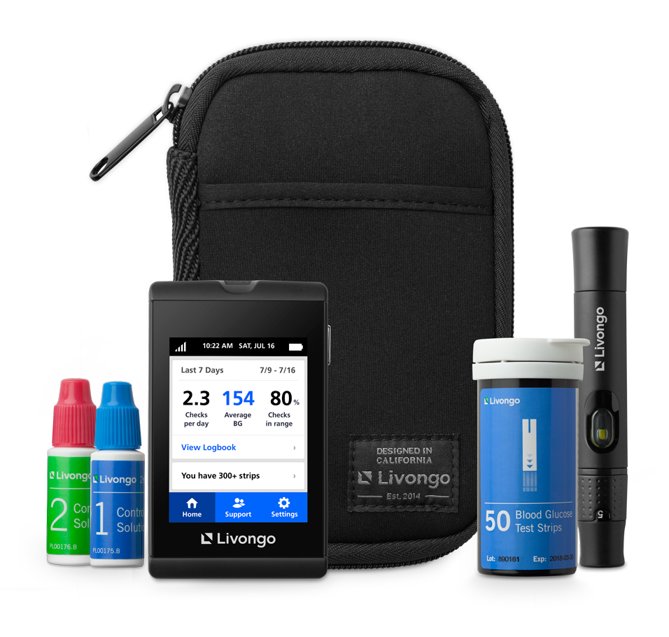
Here are some of the benefits of this program:

- More Than a Standard Meter: The Livongo meter is connected and provides real-time tips and automatically uploads your blood glucose readings, making log books a thing of the past.

- Unlimited Strips at No Cost to You: Get as many strips and lancets as you need with no hidden costs. When you are about to run out, Livongo ships more supplies, right to your door.

- Coaching Anytime and Anywhere: The Livongo coaches are Certified Diabetes Educators who are available anytime via phone, text, and our mobile app to give you guidance on your nutrition and lifestyle questions.

To Learn More or Join:
join.livongo.com/BLUEKC/now
Use registration code: BLUEKC

If you have any questions about this program, please call Livongo Member Support at (800) 945-4355 and mention registration code BLUEKC.

Thanks,
[HR NAME]

El programa Livongo está disponible en Español: Cuando se registre, usted seteará el idioma de preferencia y luego el medidor y el programa estarán en Español. Para registrarse en Español, por favor llame al (800) 945-4355 o visite bienvenido.livongo.com/BLUEKC.

PM01884.B SM1073_082619

